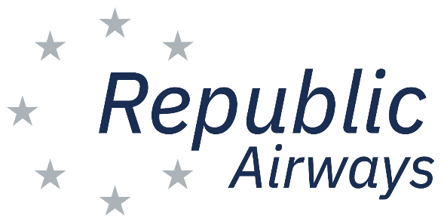

Vendor Form

Thank you for your interest as a vendor for the 2022 Republic Airways Plane Pull on Saturday, April 23, 2022. We are anticipating another wonderful event, and our participants, spectators and vendors are always a great addition. The event starts at 9 a.m., and all vendors must be moved in by 8:30 a.m. and be open between 9 a.m.-12 p.m. If you have any questions or need more information, please contact Shea Holden at (765) 810-7137 or Shea@visioneventmanagement.com.

Please contact Shea Holden for additional sizes, equipment or information:

Company: ___________________________________________________________________

Contact Name: _______________________________________________________________

Phone Number: _____________________ Email:____________________________________

Address: ____________________________________________________________________

City :_______________________________ State:_____________ Zip_____________

Activity or Product in your booth: __________________________________________________

Booth Size (circle): _____10x10____ 10X20_____20x20__

Other Space Needed: __________________________________________________________

Tables Needed: _________________________ Chairs: _______________________________

Electricity Needed (circle): ___Yes/No__ Electricity Specifications: _____________________

Volunteers Needed (circle): ____(Yes/No)____ Number of Volunteers Needed: ___________

Please return this form to: Vision Event Management

17401 Tiller Ct, Suite A

Westfield, Indiana 46074

Shea@visioneventmanagement.com

